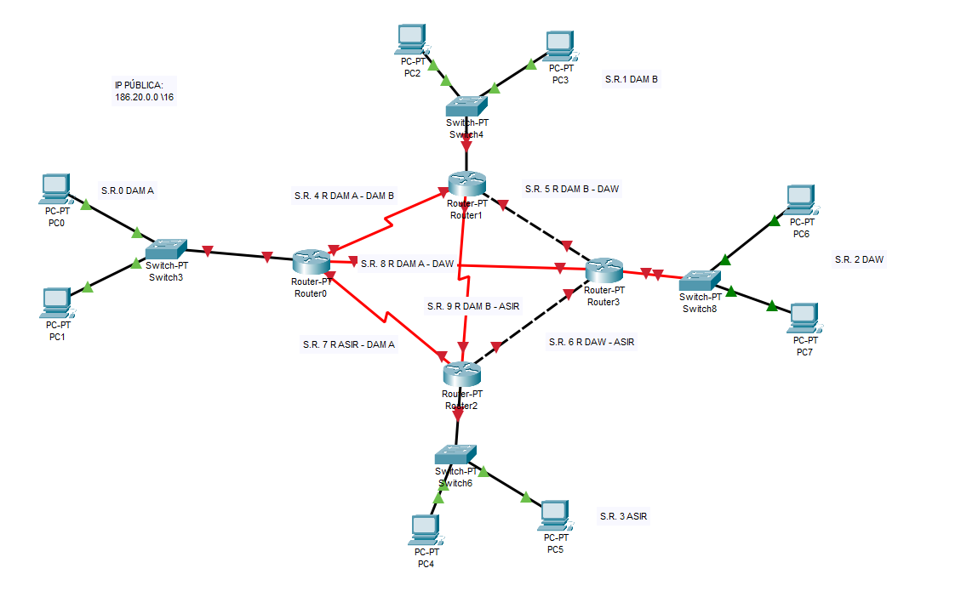
1. Calcula la información de las subredes finales:
bits host? = 2^4>=10 subredes
MÁSCARA= 11111111.11111111.11110000.00000000 = 255.255.240.0 = \ 20
NUM. HOST = 2^12 -2 = 4092
- S.R.0 DAM A
IP. RED = 186.20.00000000.00000000 = 186.20.0.0 \20
P.E. = 186.20.00000000.00000001 = 186.20.0.1 \20
B.C. = 186.20.00001111.11111111 = 186.20.15.255 \20
Ult.IP. = 186.20.00001111.11111110 = 186.20.15.254 \20

- S.R.1 DAM B
IP. RED = 186.20.00010000.00000000 = 186.20.16.0 \20
P.E. = 186.20.00010000.00000001 = 186.20.16.1 \20
B.C. = 186.20.00011111.11111111 = 186.20.31.255 \20
Ult.IP. = 186.20.00011111.11111110 = 186.20.31.254 \20

- S.R.2 DAW
IP. RED = 186.2.00100000.00000000 = 186.20.32.0 \20
P.E. = 186.20.00100000.00000001 = 186.20.32.1 \20
B.C. = 186.20.00101111.11111111 = 186.20.47.255 \20
Ult.IP. = 186.20.00101111.11111110 = 186.20.47.254 \20

- S.R.3 ASIR
IP. RED = 186.20.00110000.00000000 = 186.20.48.0 \20
P.E. = 186.20.00110000.00000001 = 186.20.48.1 \20
B.C. = 186.20.00111111.11111111 = 186.20.63.255 \20
Ult.IP. = 186.20.00111111.11111110 = 186.20.63.254 \20

2. Calcula la Ips de los Routers para las subredes:
- S.R.4 R DAM A – DAM B
IP. RED = 186.20.01000000.00000000 = 186.20.64.0 \20
IP R DAMA: 186.20.01000000.00000001 186.20.64.1 \20
IP R DAMB: 186.20.01000000.00000010 186.20.64.2 \20
- S.R.5 R DAM B – DAW
IP. RED = 186.20.01010000.00000000 = 186.20.80.0 \20
IP R DAMB: 186.20.01010000.00000001 186.20.80.1 \20
IP R DAW: 186.20.01010000.00000010 186.20.80.2 \20
- S.R.6 R DAW – ASIR
IP. RED = 186.20.01100000.00000000 = 186.20.96.0 \20
IP R DAW: 186.20.01100000.00000001 186.20.96.1 \20
IP R ASIR: 186.20.01100000.00000010 186.20.96.2 \20
- S.R.7 R ASIR– DAM A
IP. RED = 186.20.01110000.00000000 = 186.20.112.0 \20
IP R ASIR: 186.20.01110000.00000001 186.20.112.1 \20
IP R DAMA: 186.20.01110000.00000010 186.20.112.2 \20
- S.R.8 R DAM A – DAW
IP. RED = 186.2.10000000.00000000 = 186.2.128.0 \20
IP R DAMA: 186.2.10000000.00000001 186.2.128.1 \20
IP R DAW: 186.2.10000000.00000010 186.2.128.2 \20
- S.R.9 R DAM B – ASIR
IP. RED = 186.20.10010000.00000000 = 186.20.144.0 \20
IP R DAMB: 186.20.10010000.00000001 186.20.144.1 \20
IP R ASIR: 186.20.10010000.00000010 186.20.144.2 \20

186.2.63.46 \ 20 = 186.20.00111111.00000000
IP. RED = 186.20.00110000.00000000 = 186.48.0.0 \20

TABLA ENRUTAMIENTO – R DAM A

RED ORIGEN | RED  DESTINO | MÁSCARA | IP DENTRO DE LA RED | SIGUIENTE  SALTO
186.20.0.0  DAM A | 186.20.0.0  DAM A | \20 | 186.20.0.1 | NO
186.20.0.0  DAM A | 186.20.64.0  R DAMA-DAMB | \20 | 186.20.64.1 | NO
186.20.0.0  DAM A | 186.20.112.0  R ASIR-DAMA | \20 | 186.20.112.2 | NO
186.20.0.0  DAM A | 186.2.128.0  DAMA-DAW | \20 | 186.2.128.1 | NO
186.20.0.0  DAM A | 186.20.16.0  DAMB | \20 | 186.20.0.1 | 186.20.64.2  186.20.112.1  186.2.128.2
186.20.0.0  DAM A | 186.2.128.0  DAW | \20 | 186.20.0.1 | 186.20.64.2  186.20.112.1  186.2.128.2
186.20.0.0  DAM A | 186.20.48.0  ASIR | \20 | 186.20.0.1 | 186.20.64.2  186.20.112.1  186.2.128.2
186.20.16.0  DAMB | 186.20.16.0  DAMB | \20 | 186.20.16.1 | NO
186.20.16.0  DAMB | R DAMB-DAW  186.20.80.0 | \20 | 186.20.80.1 | NO
186.20.16.0  DAMB | R DAMB-ASIR  186.20.144.0 | \20 | 186.20.144.1 | NO
186.20.16.0  DAMB | 186.20.64.0  R DAMA-DAMB | \20 | 186.20.64.2 | NO
186.20.16.0  DAMB | 186.20.0.0  DAM A | \20 | 186.20.16.1 | 186.20.64.1  186.20.144.2  186.20.80.2
186.20.16.0  DAMB | 186.2.128.0  DAW | \20 | 186.20.16.1 | 186.20.64.1  186.20.144.2  186.20.80.2
186.20.16.0  DAMB | 186.20.48.0  ASIR | \20 | 186.20.16.1 | 186.20.64.1  186.20.144.2  186.20.80.2

